|  |  |
| --- | --- |
| User MANUAL  ATON (Alert about Threaten Objects Near you) | Hugo BALTZ |
|  | 8/17/2016 |

88/

Table of Contents

I. How install ATON? 2

II. How launch ATON? 4

III. How works ATON? 4

III.1 Export the point cloud: 6

III.2 Clear the point cloud: 7

III.3 Toggle the visibility: 7

III.4 Calculate the volume of a room: 8

III.5 Send a point cloud: 9

III.6 Delete a file: 11

# How install ATON?

A.T.O.N. is not available on the PlayStore, so you have to install directly the .apk on your device.(you can download it here) First, you have to allow installation of apps from unknown sources, there are the steps to achieve it:

1. Go on the device’s settings.

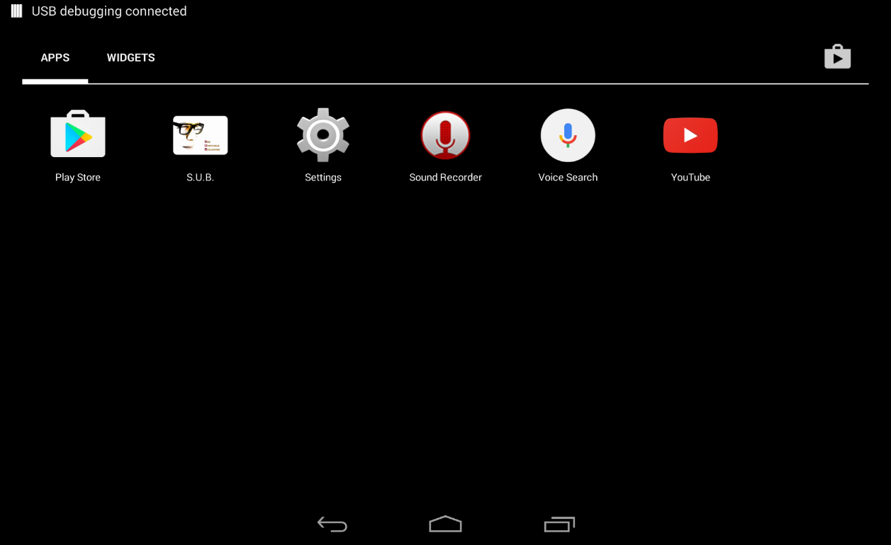

1. Then go on Personal/Security:

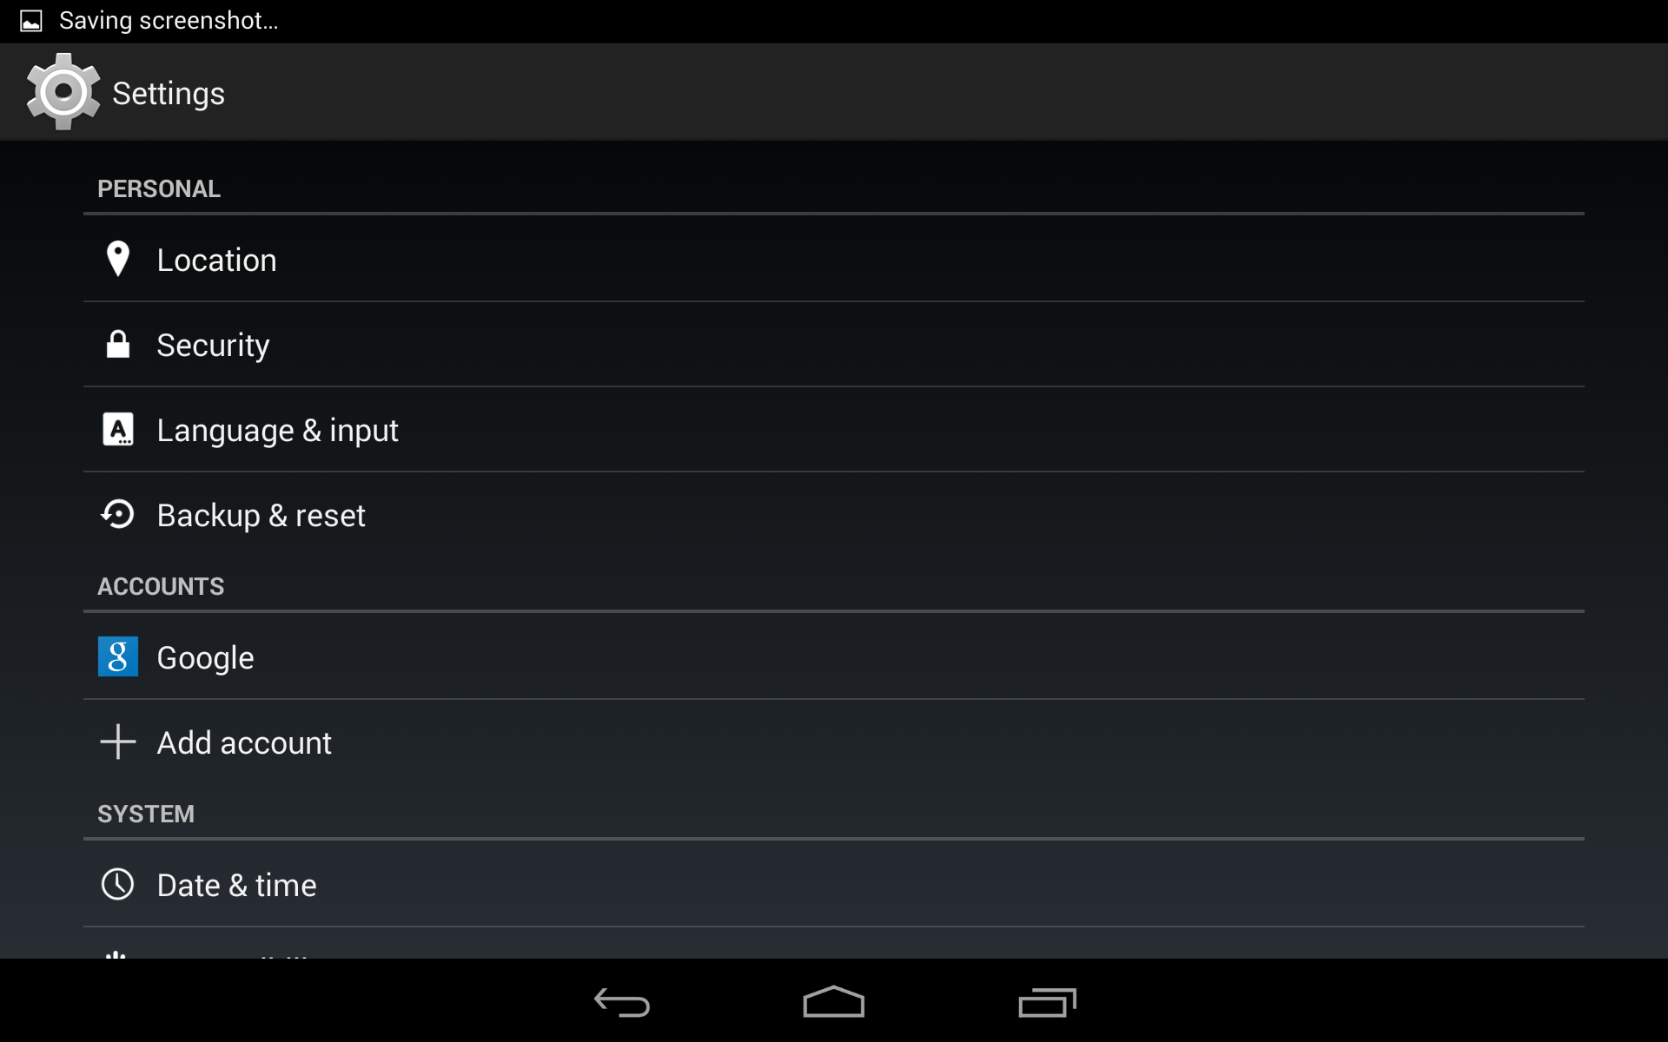

1. Then on Device administration allow Unknown sources:

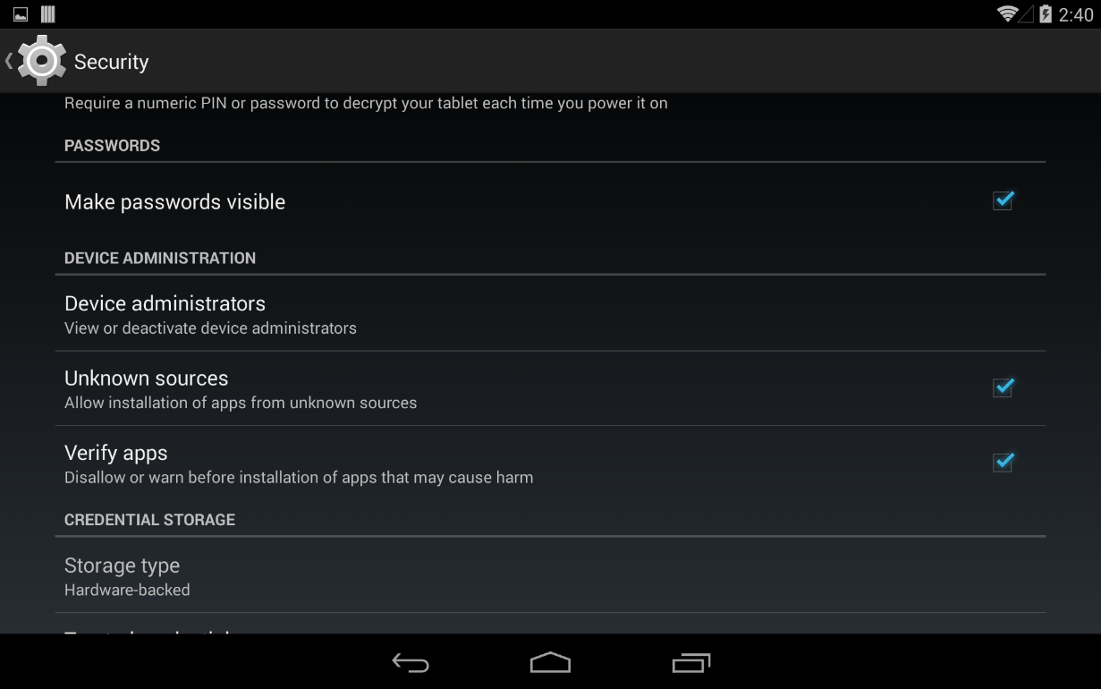

1. You can download the apk file here with your device
2. When the download process is finished, you just have to open the apk files, your devices will install it.

# How launch ATON?

To launch the application, you just have to click on the icon on your device:

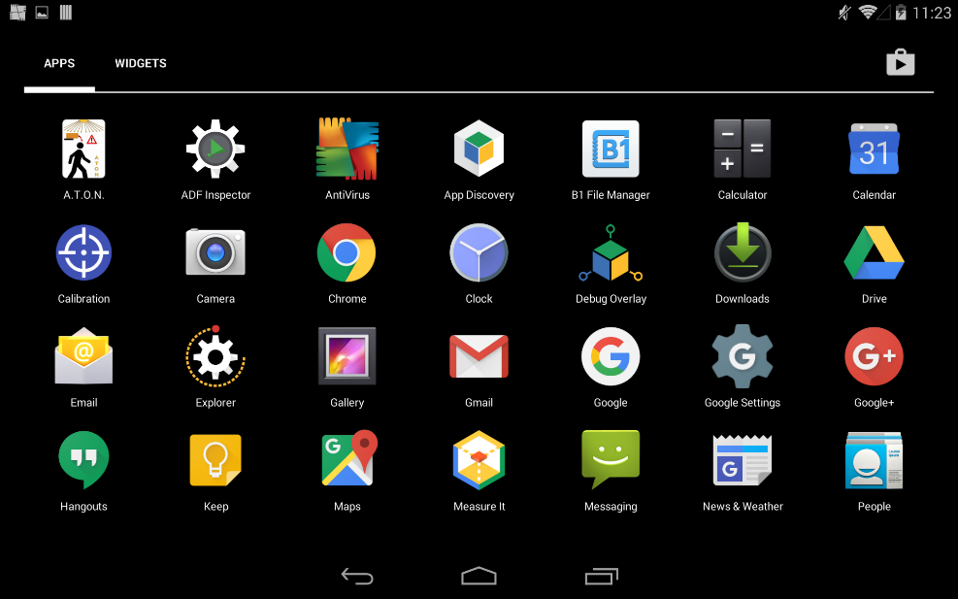

# How works ATON?

When you launch ATON, this application directly shows on augmented reality the point cloud that the project tango created using the captor of the device:

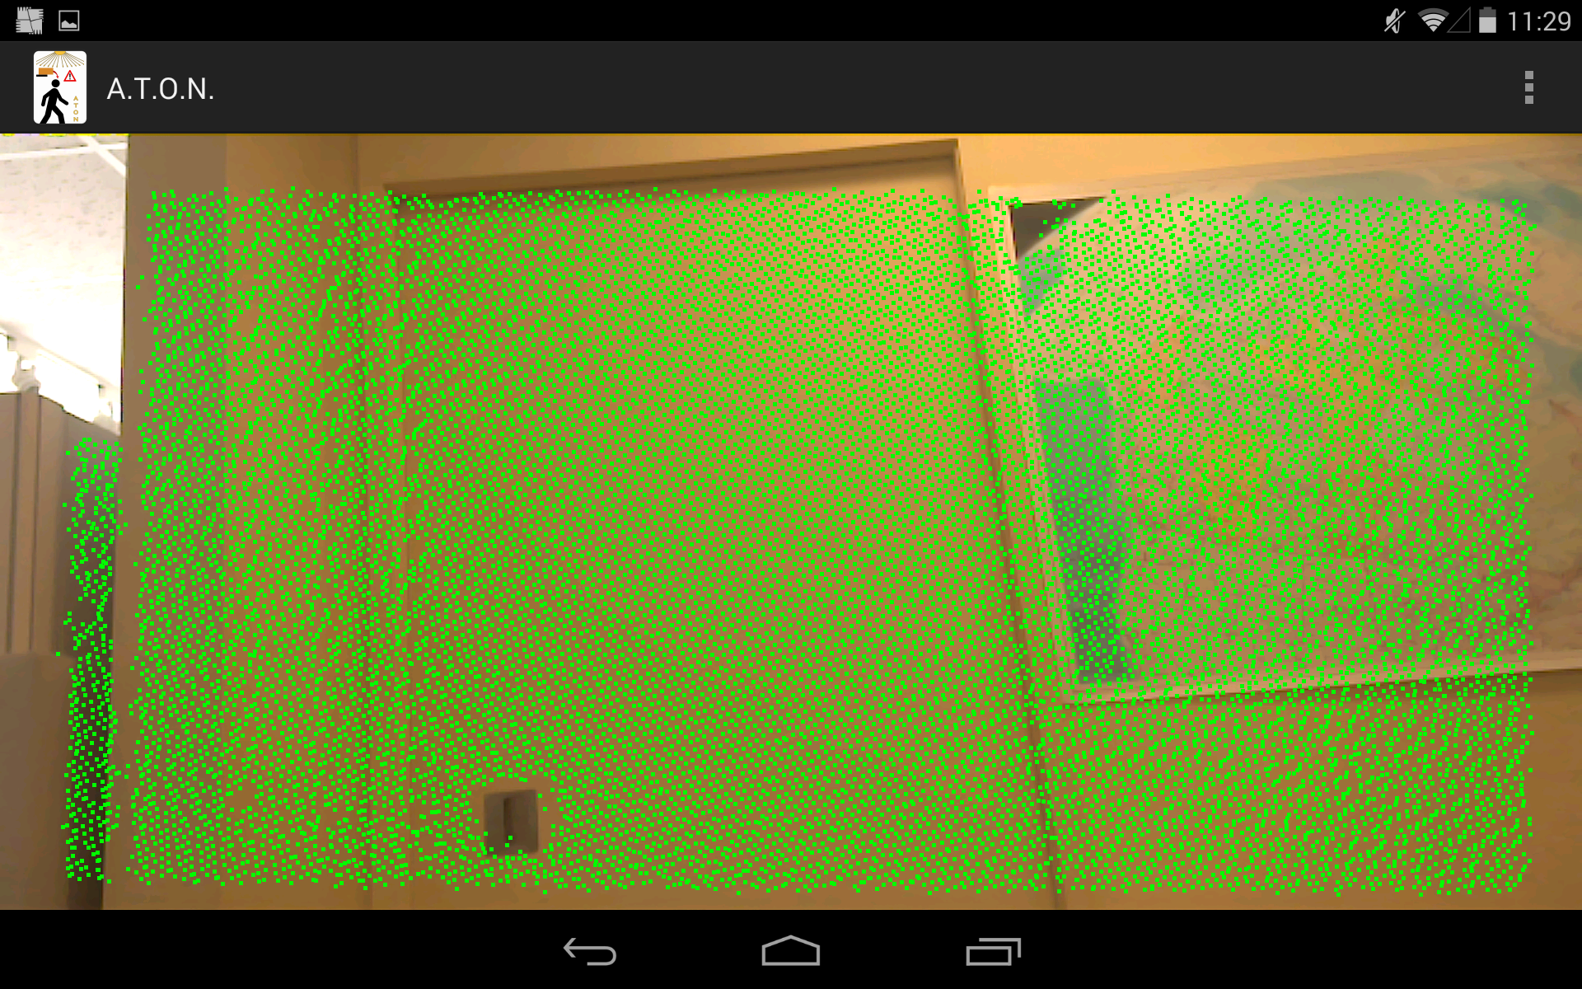

Then if you touch the screen the device adds to the point cloud stored on the device the point in green, the point cloud stores on the device appears in blue.

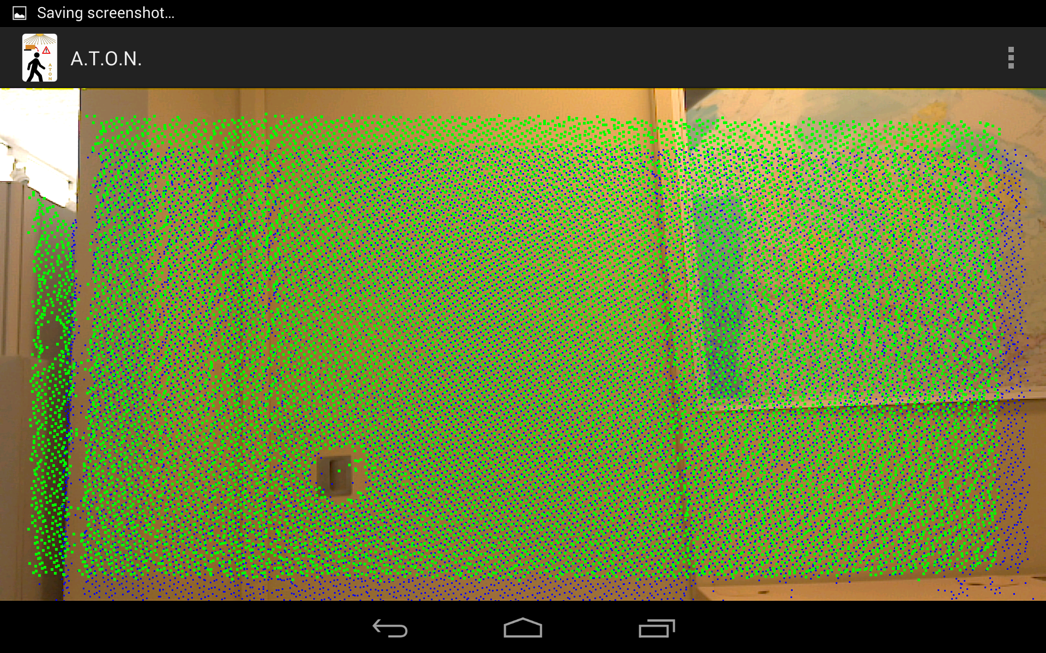

Then you have several possibilities, when you touch the three dotes on the up-right corner, you access to the menu:

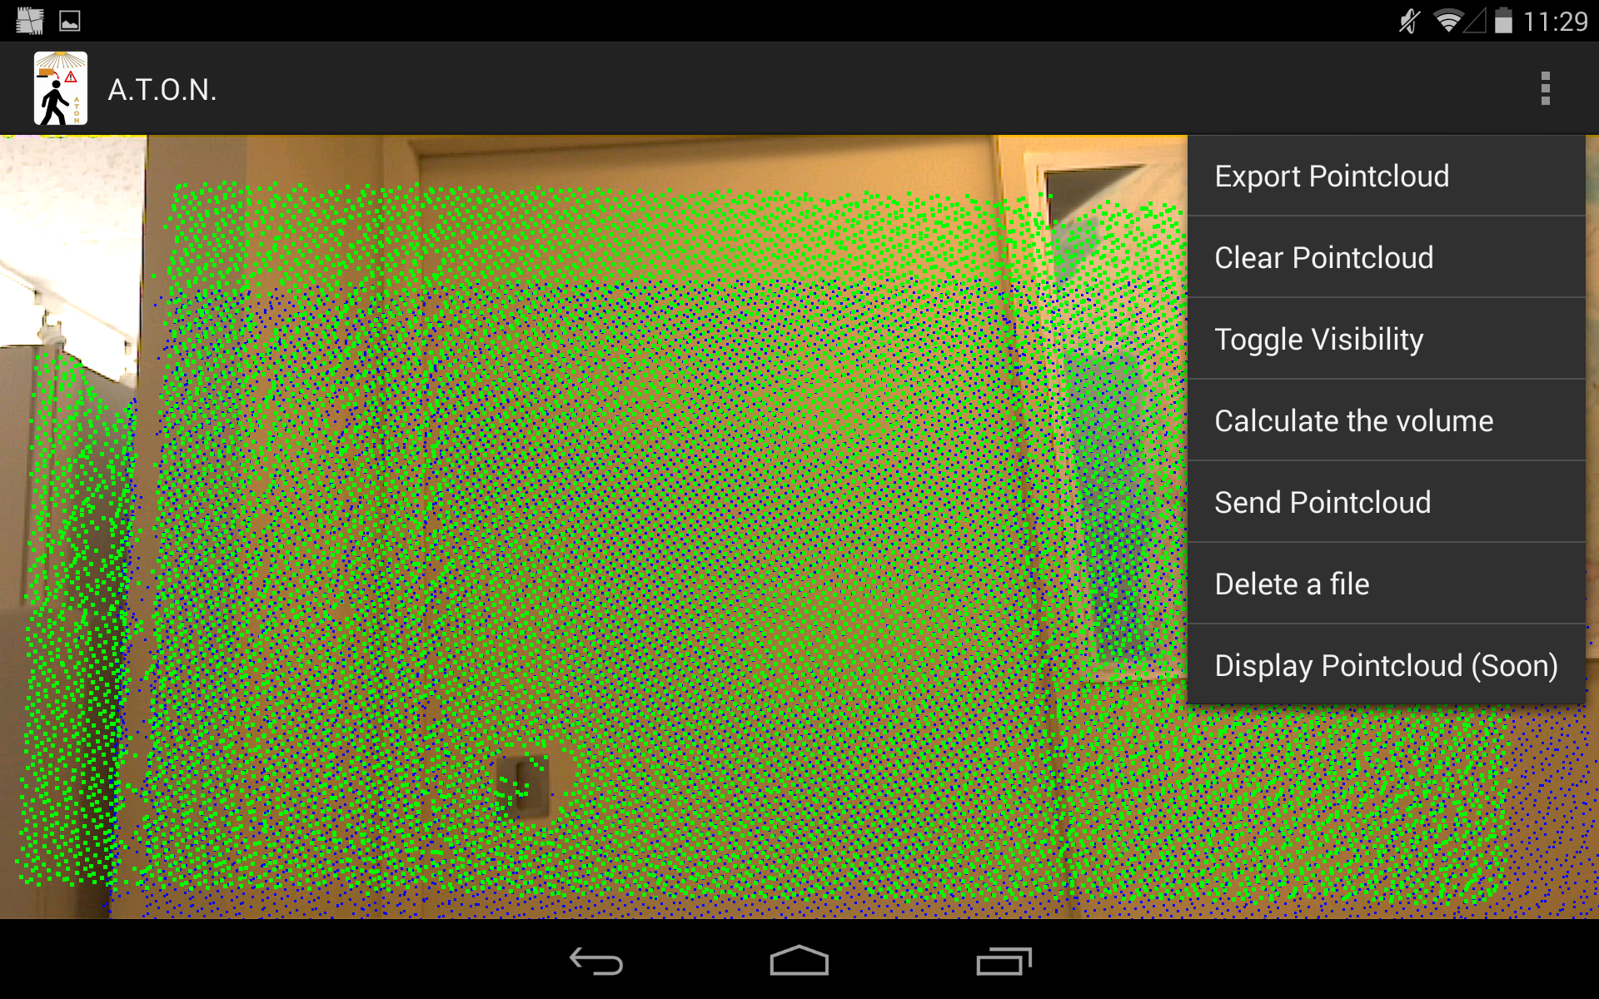

## Export the point cloud:

When you click on “Export Pointcloud”, then you want to export the point cloud stored on the device (= the blue point cloud on the screen).

When you click on it, a dialog appears, you have to enter the name that you want to give to the point cloud.

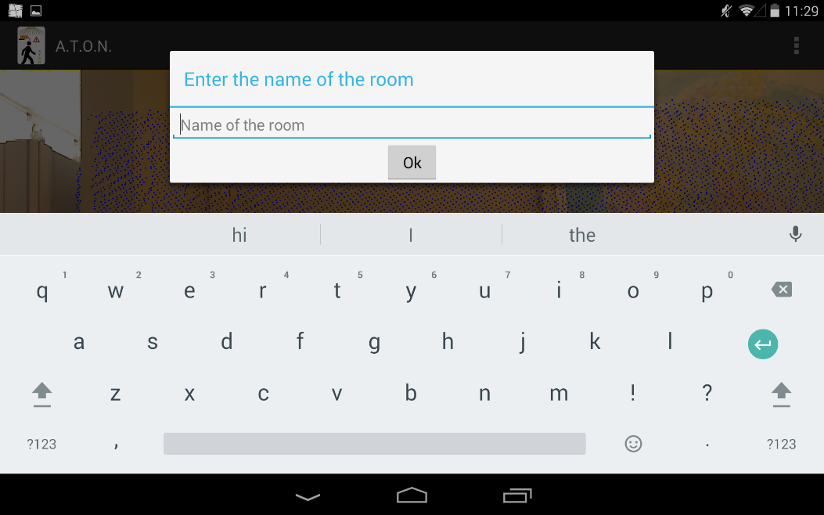

For example, here, I want to name the point cloud test:

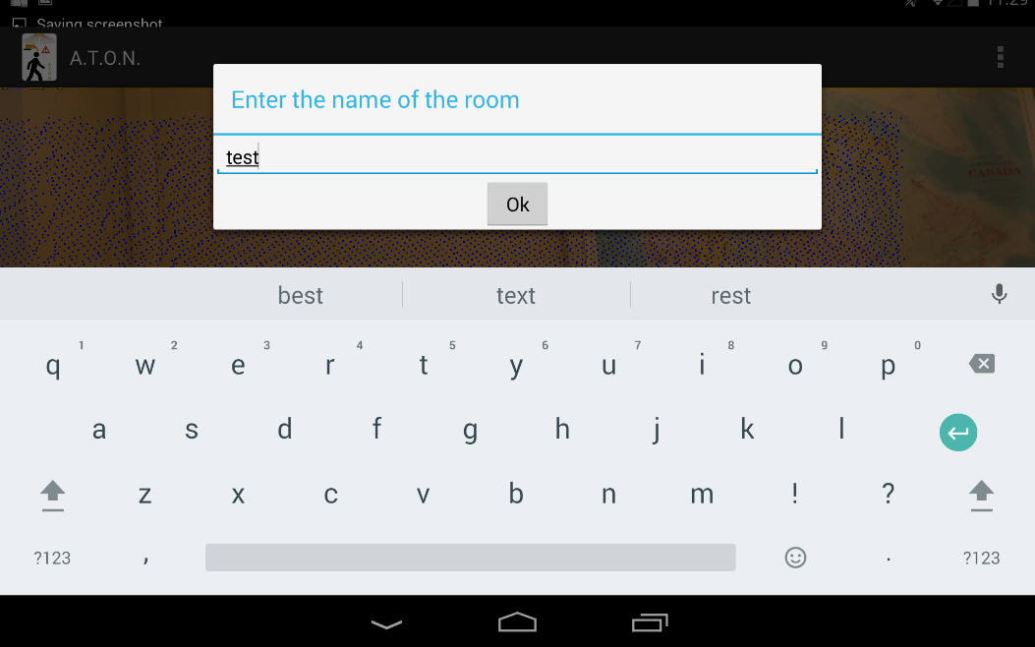

When the point cloud has been exported, then a message appears on the screen.

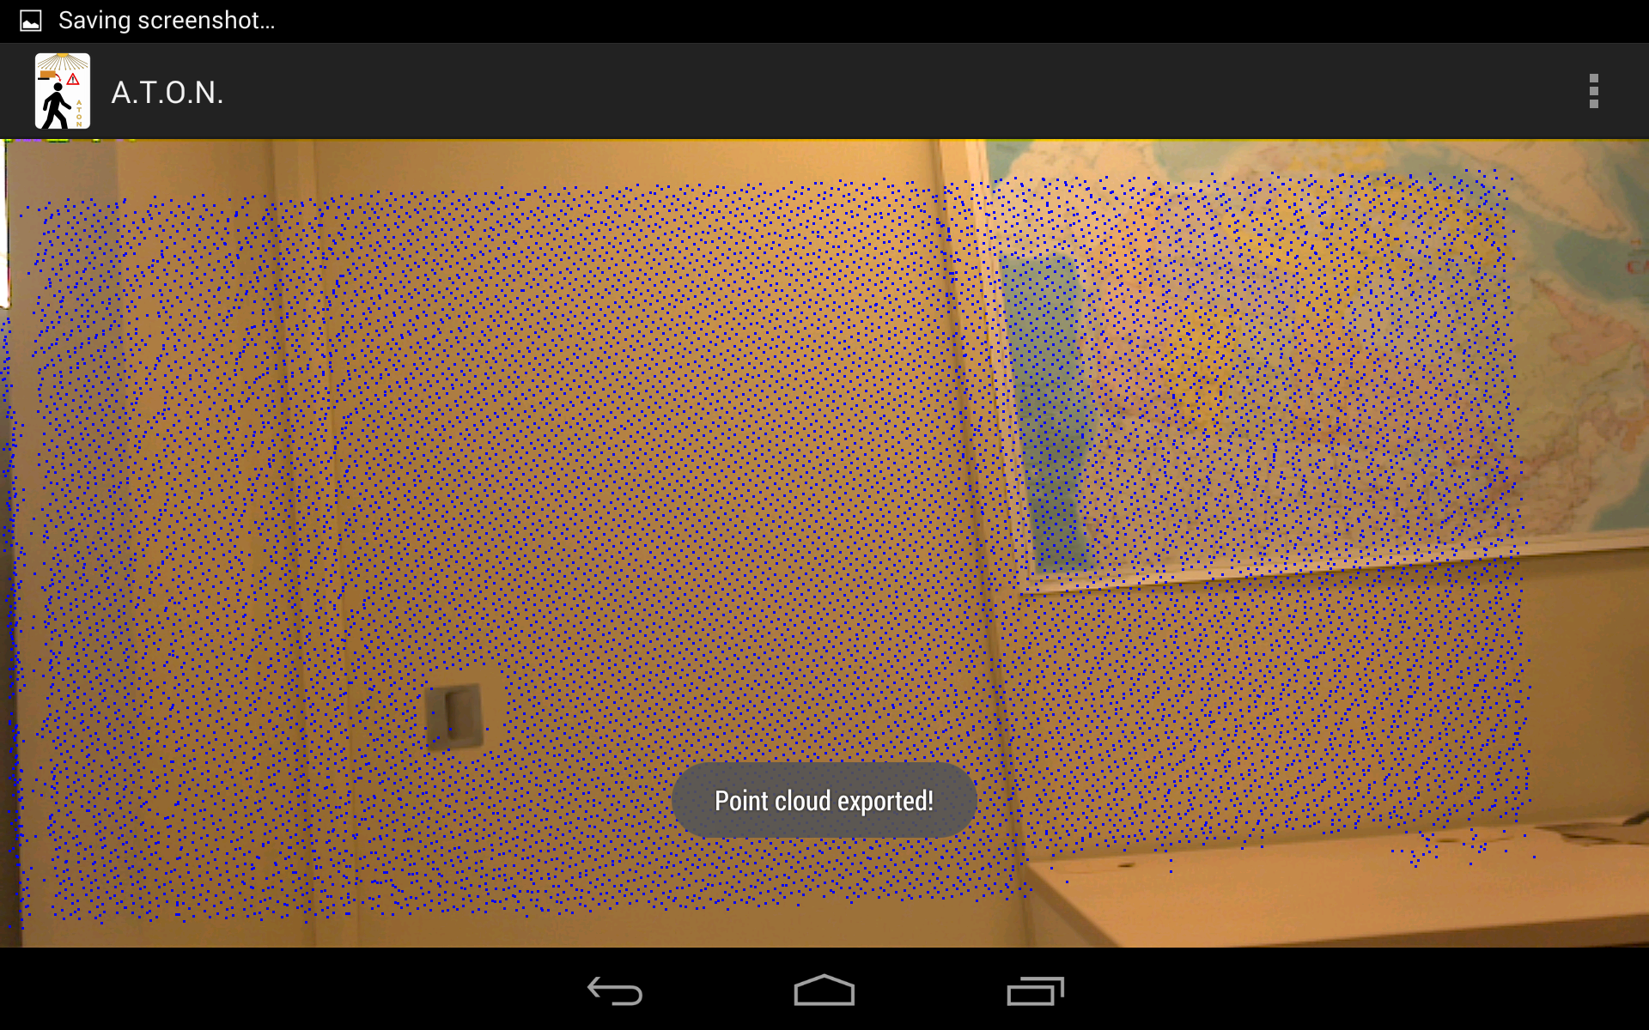

## Clear the point cloud:

When you click on “Clear Pointcloud”, then you deleted the point cloud stored on the device (+the blue point cloud) from your device.

## Toggle the visibility:

When you click on “Toggle Visibility”, you change the visibility of the green point cloud. For example, this is at append when I click on this button:

Before I click on it:



When I click on it:

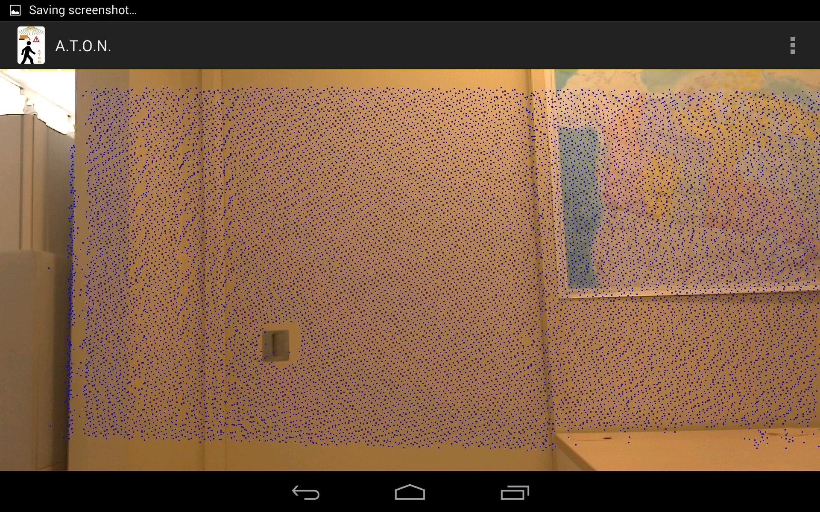

## Calculate the volume of a room:

When you have exported a point cloud you can click on the button “Calculate the volume”, when you do it a window appears on which you have to choose a room:

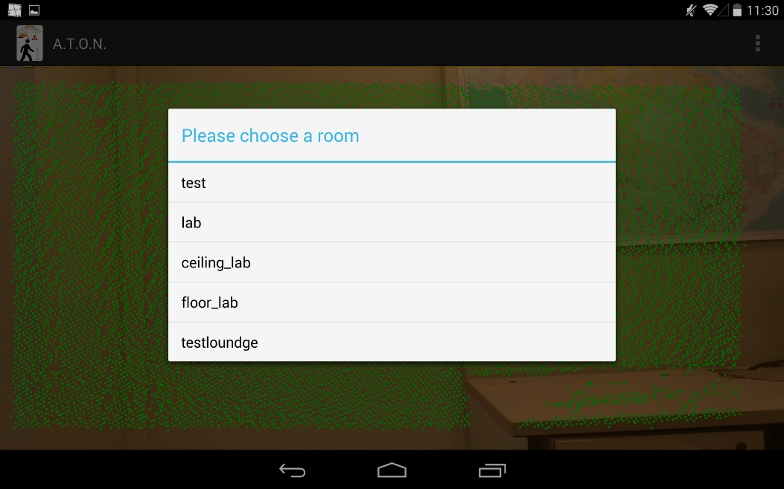

For example, here I click on “lab”, when the calculation is over, this window appears:

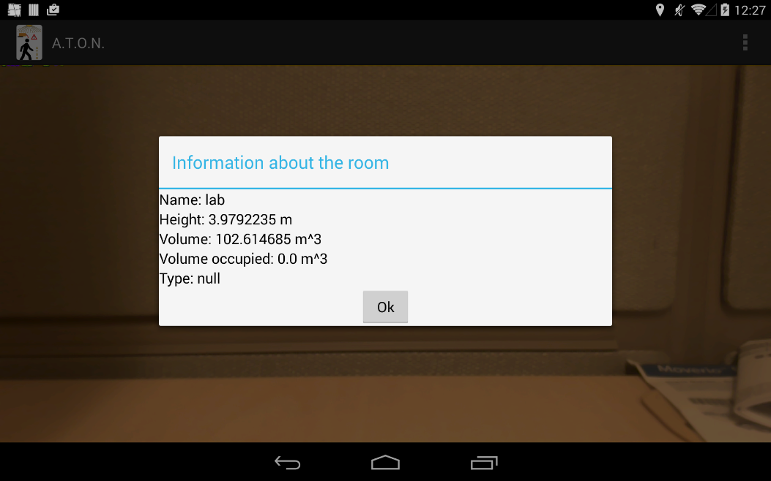

During the calculation, the application creates two other point clouds: the ceiling and the floor of the room.

## Send a point cloud:

If you want to visualize a point cloud stored on your device on your computer or to store him, you can send this point cloud via e-mail.

When you click on “Send Pointcloud”, a dialog appears where you have to pick the room thaht you want to send:



When you have pick a name, you have to enter the e-mail address on which you want to send the point cloud:

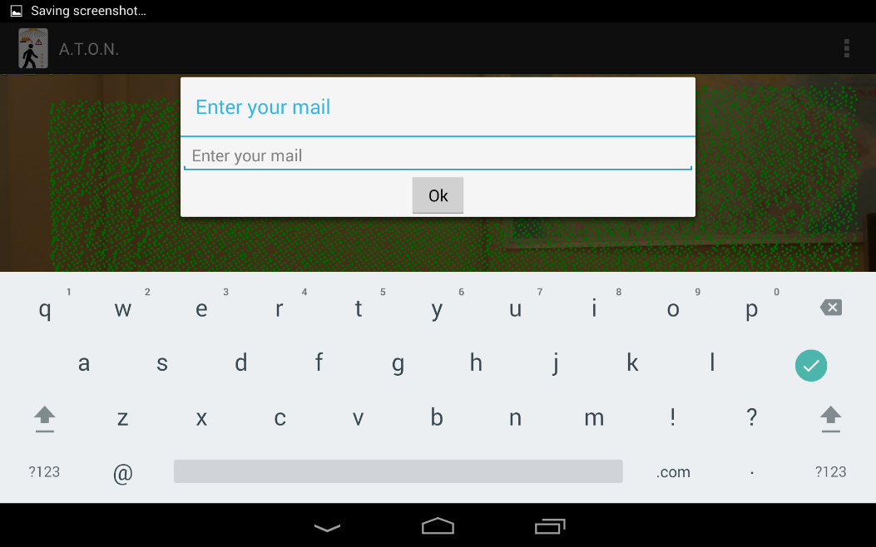

Then you have to choose the application which will send the point cloud. If the point cloud is too heavy use the google Drive application:

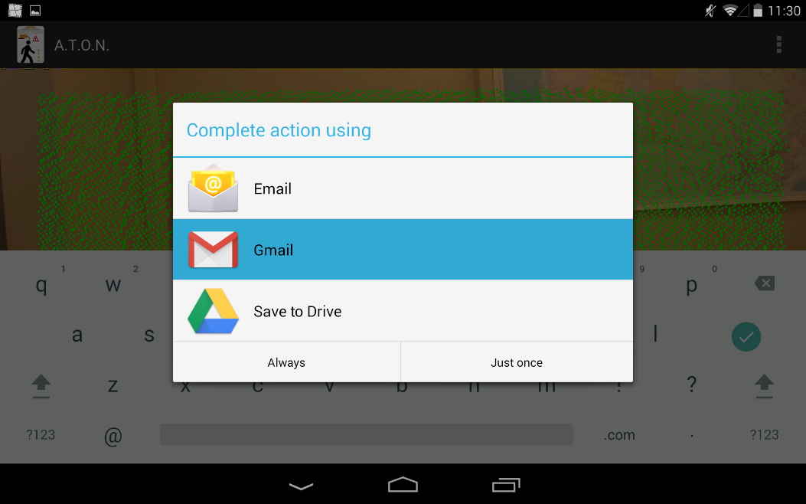

## Delete a file:

If you want to delete a point cloud that you have exported, click on “Delete a file”, then pick the point cloud that you want to delete and the point cloud will be deleted:

